POSTOPERATIVE COMPLICATIONS, RISK FACTORS, AND QUALITY OF LIFE IN PATIENTS WITH INTESTINAL STOMA: A SYSTEMATIC REVIEW AND META-ANALYSIS

ABSTRACT
The study set out to examine postoperative complications in patients with intestinal stoma, as well as risk factors and quality of life in this population using methodological standards such as systematic literature review and meta-analysis method. Published papers were searched from 2017 onward, from three databases: PubMed/MEDLINE, Scopus and Web of Science. The article review process followed the PRISMA 2020 flow diagram. Out of 295 articles extracted, 5 duplicate articles were removed, 290 articles were screened based on titles and abstracts, 70 articles were assessed in full text and 12 articles met inclusion criteria for analysis. The included articles included outcomes for early/postoperative stoma complications, high-output stoma, postoperative ileus, readmission, stoma-related obstruction, complications after stoma closure, sigmoid stoma complications after abdominoperineal resection, and patients’ quality of life. Descriptive results indicated that the majority of articles were published in 2021, with retrospective studies as the most common research design. Results from the forest plot indicated a pooled effect equal to 1.12 by using a 0.60–1.65 interval and a p < 0.001; The heterogeneity value was high (I² = 86.98%, suggesting substantial variation between articles included). The funnel plot illustrated that the distribution of the articles was not completely symmetrical. It is now acknowledged that stoma complications from intestinal stoma are affected by a number of clinical factors, stoma type, phase of care, and patient characteristics.

Keywords: Intestinal stoma, Postoperative complications, Risk factors, Quality of life, Meta-analysis.

INTRODUCTION
Intestinal stoma is a surgical procedure that creates a connection between the intestinal lumen and the abdominal wall to divert the passage of feces or intestinal contents, either temporarily or permanently. This procedure is commonly performed in patients with colorectal cancer, inflammatory bowel disease, abdominal trauma, obstruction, perforation, anal sphincter dysfunction, and other emergency conditions requiring intestinal diversion. Although a stoma can be life-saving and support postoperative recovery, its presence is not merely a technical surgical issue. Qassim et al. (2023) explained that stoma complications are relatively high compared with other surgical procedures, with an average rate of approximately 40% and a range of 14–79%, while Elnaim et al. (2024) reported that stoma complications may reach 10–70% and include skin irritation, infection, necrosis, stenosis, prolapse, retraction, parastomal hernia, and nutritional problems in high-output stoma. This wide range indicates that morbidity after stoma formation remains an important clinical issue and cannot yet be predicted uniformly across different patient populations.
Postoperative complications in patients with intestinal stoma require serious attention because they may occur from the early phase after surgery to the later phase when patients return to their daily activities. Early complications such as peristomal dermatitis, mucocutaneous separation, stoma bleeding, infection, edema, necrosis, and stoma obstruction can interfere with wound healing, prolong hospitalization, increase the need for follow-up consultations, and add to the burden of care. Ambe et al. (2022) showed that preoperative stoma site marking was associated with a reduction in overall stoma and peristomal complications, with an OR of 0.519 and 95% CI of 0.421–0.640; a protective effect was also observed for early and late complications in fecal stomas. Nozawa et al. (2024) strengthened these findings in emergency surgery, reporting that grade ≥2 complications were lower in the group receiving stoma site marking than in the group without marking, at 24% versus 36%, and that the absence of marking was an independent risk factor for stoma complications, with an adjusted OR of 1.69. These findings provide a basis that preoperative technical factors and the quality of surgical preparation have a direct role in patient morbidity.
Faktor risiko komplikasi intestinal stoma tidak hanya terkait teknik pembedahan, tetapi juga karakteristik pasien, jenis stoma, lokasi stoma, dan kondisi klinis pascaoperasi. Dellafiore et al. (2022) menyusun systematic review mengenai faktor risiko komplikasi intestinal stoma dan menekankan perlunya penilaian kritis terhadap faktor yang berhubungan dengan munculnya komplikasi ostomy. Gan et al. (2025) melakukan meta-analisis stoma outlet obstruction setelah colorectal surgery dengan diverting ileostomy dan menggunakan OR serta 95% CI melalui random-effects model, terutama untuk faktor risiko yang dilaporkan minimal oleh dua artikel. Toffaha et al. (2025) juga melaporkan bahwa ketebalan rectus abdominis muscle meningkatkan risiko stoma outlet obstruction dengan OR 4,04, sehingga aspek anatomi dinding abdomen perlu dipertimbangkan saat menilai risiko pascaoperasi. Zhou et al. (2023) menunjukkan bahwa usia ≥60 tahun, stadium tumor IV, ASA ≥3, neoadjuvant chemoradiotherapy, open surgery, postoperative chemotherapy, anastomotic leakage, dan local recurrence berkaitan dengan risiko non-closure stoma, sehingga masalah stoma dapat berlanjut hingga keputusan reversal atau penutupan stoma.
Komplikasi peristomal skin disorder menjadi salah satu masalah paling sering dan paling mengganggu karena berkaitan langsung dengan kebocoran kantong, nyeri, bau, rasa malu, serta kegagalan perekat stoma appliance. Brady et al. (2025) melaporkan beban penyakit yang tinggi pada orang dengan stoma baru, terutama saat kebocoran berulang dan peristomal skin complications berat muncul pada tahun pertama setelah operasi. Poliani et al. (2026) menyatakan bahwa kebocoran stoma masih banyak dialami pasien, bahkan studi yang dirujuknya mencatat 57% pasien mengalami kebocoran siang hari dan 61% kebocoran malam hari. Shiraishi et al. (2025) memberi bukti lebih rinci melalui prospective multicenter observational study pada pasien kanker rektum dengan stoma, yaitu loop stoma, tinggi stoma <10 mm, dan kemoterapi berhubungan secara independen dengan kejadian peristomal skin disorders; diabetes mellitus juga menjadi faktor risiko perburukan, sedangkan tinggi stoma <10 mm berkaitan dengan perkembangan kelainan kulit yang lebih berat. Data ini memperlihatkan bahwa luaran kulit peristomal layak diperlakukan sebagai outcome kuantitatif tersendiri pada meta-analisis, bukan sekadar komplikasi minor.
Risk factors for intestinal stoma complications are not only related to surgical technique, but also to patient characteristics, stoma type, stoma location, and postoperative clinical conditions. Dellafiore et al. (2022) conducted a systematic review of risk factors for intestinal stoma complications and emphasized the need for critical assessment of factors associated with the occurrence of ostomy complications. Gan et al. (2025) conducted a meta-analysis of stoma outlet obstruction after colorectal surgery with diverting ileostomy using OR and 95% CI through a random-effects model, particularly for risk factors reported by at least two articles. Toffaha et al. (2025) also reported that rectus abdominis muscle thickness increased the risk of stoma outlet obstruction, with an OR of 4.04, indicating that anatomical aspects of the abdominal wall should be considered when assessing postoperative risk. Zhou et al. (2023) showed that age ≥60 years, stage IV tumor, ASA ≥3, neoadjuvant chemoradiotherapy, open surgery, postoperative chemotherapy, anastomotic leakage, and local recurrence were associated with the risk of non-closure stoma, indicating that stoma-related problems may continue until the decision for reversal or stoma closure.
Peristomal skin disorder is one of the most frequent and disturbing problems because it is directly related to pouch leakage, pain, odor, embarrassment, and failure of the stoma appliance adhesive. Brady et al. (2025) reported a high disease burden among people with a new stoma, particularly when recurrent leakage and severe peristomal skin complications occurred during the first year after surgery. Poliani et al. (2026) stated that stoma leakage is still commonly experienced by patients; a study cited in their work reported that 57% of patients experienced daytime leakage and 61% experienced nighttime leakage. Shiraishi et al. (2025) provided more detailed evidence through a prospective multicenter observational study of rectal cancer patients with stoma, showing that loop stoma, stoma height <10 mm, and chemotherapy were independently associated with the incidence of peristomal skin disorders; diabetes mellitus was also a risk factor for worsening conditions, while stoma height <10 mm was associated with the development of more severe skin disorders. These data show that peristomal skin outcomes should be treated as a separate quantitative outcome in meta-analysis, rather than merely as minor complications.
Late complications such as parastomal hernia, prolapse, stenosis, and problems during stoma closure also have major clinical and economic impacts. Glynn et al. (2025) reported that parastomal hernia reduced health-related quality of life in the domains of pain/discomfort, daily activities, self-care, mobility, and anxiety/depression. Jose et al. (2025) highlighted a more specific issue in stoma closure, namely peristomal Candida infection as a risk factor for surgical site infection after stoma closure. Zeng et al. (2025) showed that in infantile enterostomy, small-intestinal stoma was a strong risk factor for enterostomy complications, with an OR of 6.405 and 95% CI of 1.647–24.916. Although pediatric populations need to be analyzed separately from adult populations, this finding emphasizes the importance of stoma location as a risk variable. Therefore, research on intestinal stoma complications needs to distinguish between the stoma formation phase, the period of living with a stoma, and the closure phase so that risk estimates are not mixed across different clinical periods.
Quality of life in patients with intestinal stoma is an important outcome because patients do not only face anatomical changes, but also changes in body image, eating habits, social activities, sexual relationships, sleep, work, and feelings of safety during activities. Zewude et al. (2021) showed that patients with stoma experience dietary adjustments and life changes related to quality of life. Leite Junior et al. (2025) found that among older adults with intestinal stoma, the mean total quality of life score was 6.71 ± 1.64; the physical domain was among the most affected areas, and patients with ileostomy had lower quality of life scores than those with colostomy. Lupo et al. (2025) added that age ≥65 years and permanent stoma were associated with higher quality of life scores, while perceived stress was negatively correlated with quality of life; pain and social embarrassment were also associated with higher stress. Açil et al. (2025) showed through path analysis that stoma function and work/social life influenced psychological aspects, physical activity, symptoms, and quality of life in colorectal cancer patients with stoma.
Although evidence regarding complications, risk factors, and quality of life among stoma patients continues to grow, research gaps remain in outcome separation and the inconsistency of statistical reporting. Ambe et al. (2022) focused their meta-analysis on stoma site marking, Gan et al. (2025) focused their synthesis on stoma outlet obstruction, and Díaz-Sánchez et al. (2026) focused their meta-analysis on the impact of ostomy on quality of life in colorectal cancer patients. Sritan (2023) examined factors affecting quality of life in colorectal cancer patients with stoma through an integrative review, but this focus has not yet integrated postoperative complications, clinical risk factors, and quality of life as a continuum of patient outcomes. This gap indicates the need for a systematic literature review and meta-analysis that integrates quantitative evidence based on OR, RR, HR, 95% CI, p-values, event data, and quality of life scores, while separating the analysis between general complications, specific complications, risk factors, and quality of life so that the pooled estimates are more clinically meaningful. This study aims to analyze postoperative complications, risk factors, and quality of life in patients with intestinal stoma through a systematic literature review and meta-analysis.
RESEARCH METHOD
This study used a systematic literature review and meta-analysis design to analyze postoperative complications, risk factors, and quality of life in patients with intestinal stoma. Meta-analysis was selected because this study not only identified and assessed previous articles, but also combined quantitative data from primary studies to obtain stronger effect estimates regarding the association between risk factors, stoma complications, and patients’ quality of life. The reporting of this study referred to the PRISMA 2020 guidelines, as these guidelines are used to improve the completeness of reporting in systematic reviews and meta-analyses, particularly in the processes of identification, screening, eligibility assessment, and inclusion of scientific articles. Page et al. (2021) explained that PRISMA 2020 provides updated reporting guidance for systematic reviews involving quantitative synthesis.
The quantitative analysis was conducted based on the principles of meta-analysis in clinical research, namely the pooling of effect sizes from primary studies with comparable populations, risk factors, comparators, and outcomes. Higgins et al. (2024) explained that meta-analysis is used to combine the results of multiple studies through the selection of effect measures, calculation of pooled estimates, and assessment of variations in results across studies. This study focused on articles reporting statistical data in the form of odds ratios (OR), p-values, and confidence intervals (CI). Therefore, the final results were not limited to literature mapping, but also included statistical estimates of factors that increase or decrease the risk of complications and poor quality of life in patients with intestinal stoma.
The research stages included: (1) formulation of the meta-analysis question, (2) article search in scientific databases, (3) article selection based on inclusion and exclusion criteria, (4) quantitative data extraction, (5) risk of bias assessment, (6) effect size calculation, (7) heterogeneity analysis, and (8) interpretation of the meta-analysis results. The article search process was conducted systematically in three major databases relevant to medical, surgical, and clinical epidemiology topics, namely PubMed/MEDLINE, Scopus, and Web of Science. The search was limited to articles published from 2017 onward, articles written in English and/or Indonesian, peer-reviewed articles, and studies with quantitative designs such as prospective cohort, retrospective cohort, case-control studies, analytical cross-sectional studies, registry-based studies, and observational comparative studies. Articles in the form of systematic reviews, scoping reviews, meta-analyses, narrative reviews, editorials, letters to the editor, case reports, and case series were not included as primary data because they did not provide primary data suitable for effect size calculation.
Keyword development was carried out using the PICO approach as follows.
Table 1. PICO Framework of the Study
Component | Information
P (Population) | Patients with intestinal stoma, including ileostomy, colostomy, jejunostomy, enterostomy, loop stoma, end stoma, temporary stoma, or permanent stoma.
I (Intervention) | Clinical, technical, and treatment risk factors related to complications or quality of life, such as stoma type, emergency surgery, elective surgery, stoma-site marking, diabetes mellitus, obesity, ASA score, chemotherapy, radiotherapy, loop stoma, end stoma, and stoma height.
C (Comparison) | Group without risk factors, reference group, comparison stoma type, patients without complications, or patients with better quality of life.
O (Outcome) | Postoperative complications, stoma-related complications, peristomal skin complications, mucocutaneous separation, stoma necrosis, retraction, prolapse, parastomal hernia, high-output stoma, stoma outlet obstruction, readmission, surgical site infection, stoma closure/reversal complications, and poor quality of life.
Keywords were combined using the Boolean operators AND and OR. The main search strategy was designed to retrieve articles discussing intestinal stoma, postoperative complications, risk factors, and quality of life with statistical data that could be included in the meta-analysis.

Table 2. Number of Articles by Search Database
Database | Keyword | Number of Articles
PubMed/MEDLINE | (“intestinal stoma” OR ostomy OR stoma OR ileostomy OR colostomy OR enterostomy) AND (“postoperative complications” OR “stoma-related complications” OR “peristomal skin complications” OR “mucocutaneous separation” OR “parastomal hernia” OR “high-output stoma” OR readmission OR “surgical site infection”) AND (“risk factors” OR predictor OR determinants OR “odds ratio” OR “confidence interval” OR “quality of life” OR HRQoL OR “Stoma-QOL”) | 92
Scopus | TITLE-ABS-KEY (“intestinal stoma” OR ostomy OR ileostomy OR colostomy OR enterostomy) AND TITLE-ABS-KEY (“postoperative complication” OR “stoma-related complication” OR “peristomal skin complication” OR “parastomal hernia” OR “high-output stoma” OR retraction OR prolapse OR necrosis OR readmission) AND TITLE-ABS-KEY (“risk factor” OR predictor OR determinant OR “quality of life” OR HRQoL OR “odds ratio” OR “confidence interval”) AND PUBYEAR > 2016 | 118
Web of Science | TS=(“intestinal stoma” OR ostomy OR ileostomy OR colostomy OR enterostomy) AND TS=(“postoperative complication” OR “stoma-related complication” OR “peristomal skin complication” OR “mucocutaneous separation” OR “parastomal hernia” OR “high-output stoma” OR readmission OR “surgical site infection”) AND TS=(“risk factor” OR predictor OR determinant OR “quality of life” OR HRQoL OR “Stoma-QOL”) | 85
Total articles identified |  | 295
The initial search in PubMed/MEDLINE, Scopus, and Web of Science yielded 295 articles, consisting of 92 articles from PubMed/MEDLINE, 118 articles from Scopus, and 85 articles from Web of Science. After duplicate checking, 5 duplicate articles were identified, leaving 290 articles for title and abstract screening. At this stage, 220 articles were excluded because they were not relevant to the research focus, did not discuss intestinal stoma, did not evaluate postoperative complications or risk factors, did not report quality of life, did not provide OR, p-value, and CI data, or had inappropriate publication designs, such as reviews, case reports, editorials, and case series. Therefore, 70 articles proceeded to the full-text assessment stage.
The PRISMA diagram was used to illustrate the number of articles obtained from each database, duplicate articles removed, articles excluded during the screening stage, articles assessed in full text, and final articles included in the quantitative meta-analysis. This diagram will be completed after the article search and selection process has been finalized.

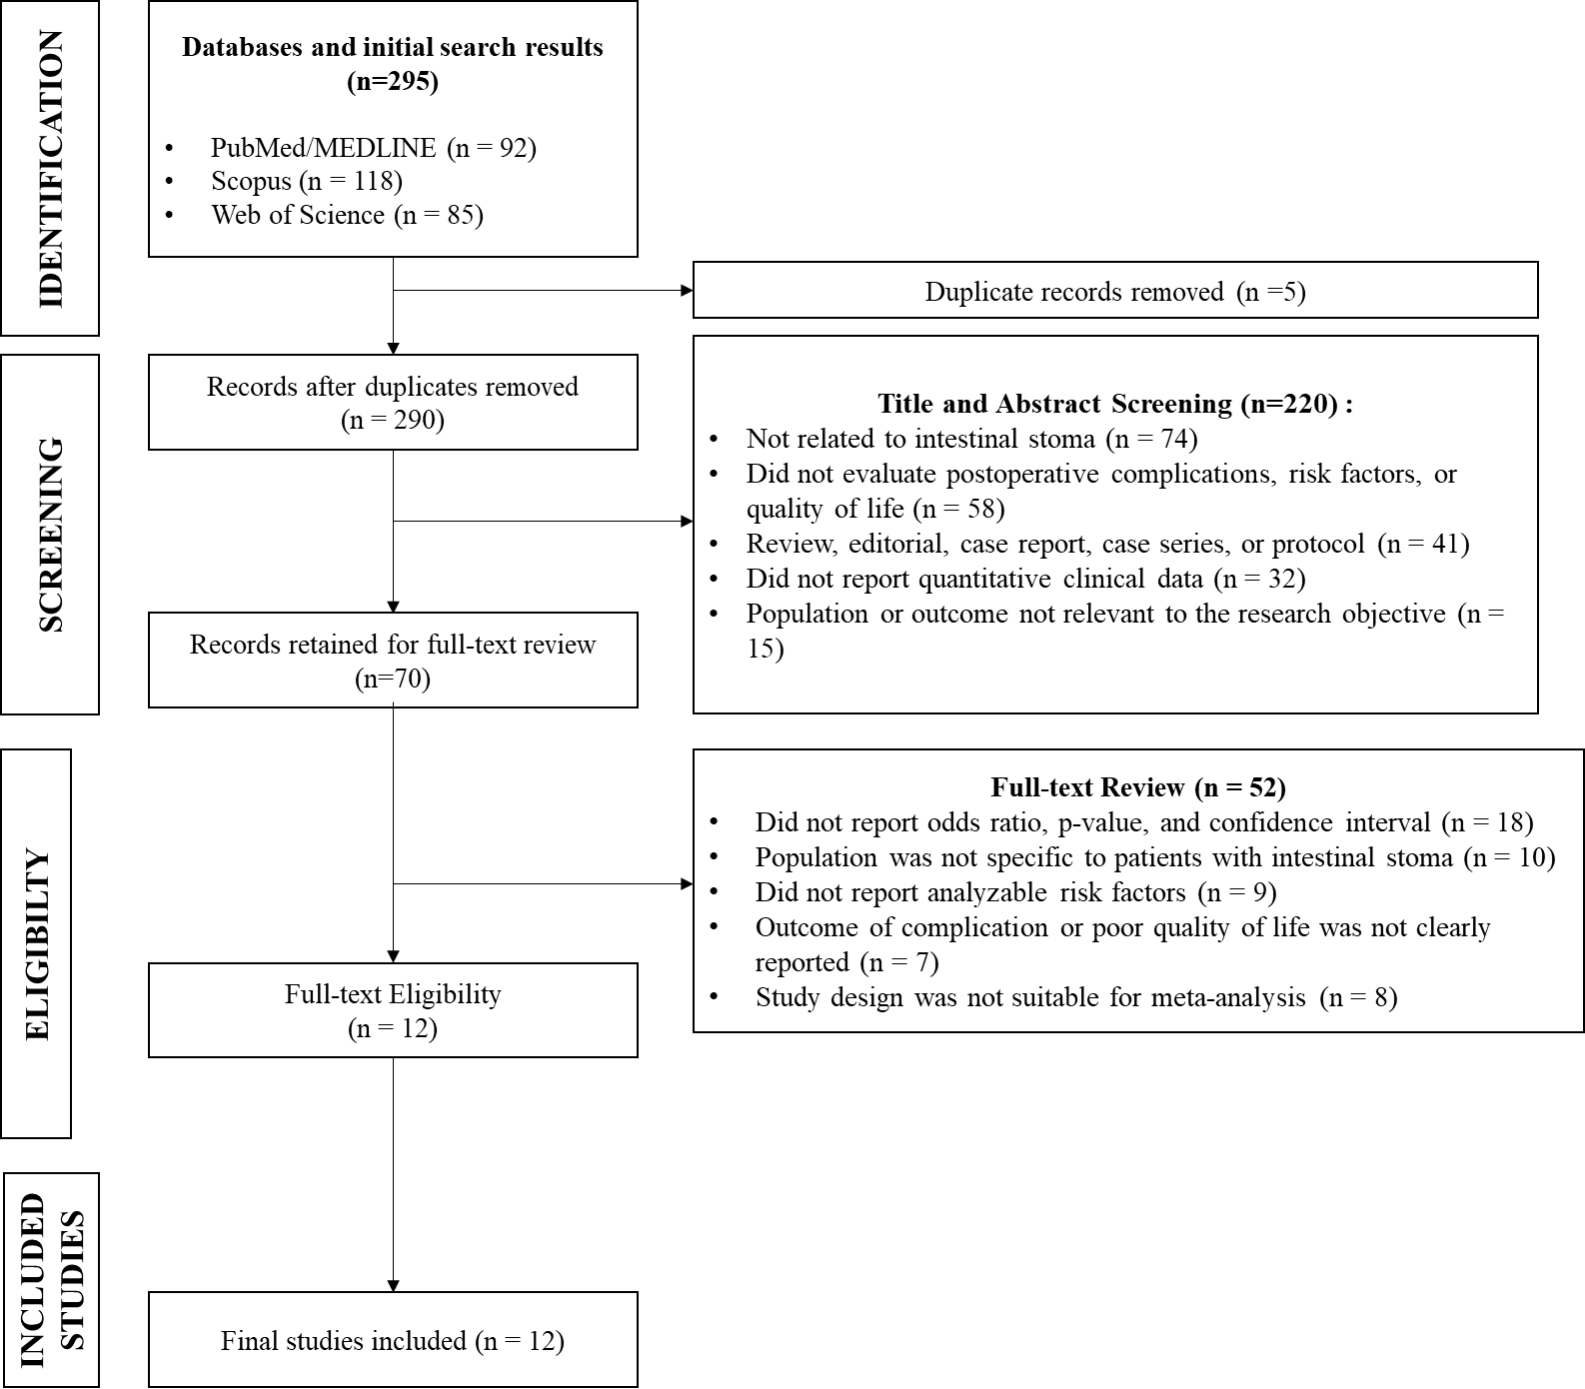
Figure 1. PRISMA diagram
At the full-text evaluation stage, 58 articles were excluded for several reasons: 18 articles did not present odds ratio (OR), p-value, and confidence interval (CI) values; 10 articles did not have a population specific to patients with intestinal stoma; 9 articles did not report risk factors that could be analyzed; 7 articles did not clearly report complication or quality-of-life outcomes; 8 articles had inappropriate study designs; and 6 articles did not provide full-text access. After the entire selection process was completed, 12 articles met the inclusion criteria and were included in the meta-analysis.
The inclusion criteria in this study were: (1) articles published from 2017 onward; (2) articles were primary quantitative studies; (3) the study population consisted of patients with intestinal stoma; (4) articles discussed postoperative complications, risk factors, or quality of life in stoma patients; (5) articles reported OR, p-value, and CI values or data that could be calculated into OR; (6) articles were available in full text; and (7) articles were written in English or Indonesian. The exclusion criteria were: (1) articles in the form of reviews, systematic reviews, meta-analyses, editorials, letters, protocols, case reports, or case series; (2) articles that did not separate data on stoma patients from other surgical populations; (3) articles that only discussed stoma device techniques or stoma education without clinical outcomes; (4) articles that did not provide OR, p-value, and CI values; and (5) duplicate articles from the same dataset.
Data extraction was performed using Microsoft Excel by recording the author’s name, publication year, country, study design, sample size, type of stoma, risk factors analyzed, type of complication or poor quality of life, and key statistical data, including odds ratio (OR), p-value, confidence interval (CI), and I². The final data were organized so that they could be directly used in the meta-analysis and presented through a forest plot containing the OR of each article, CI, p-value, study weight, pooled estimate, and heterogeneity value of I². Data analysis was conducted using JASP, in which the OR and CI values from each article were entered as the main effect measures and then analyzed to obtain the pooled OR, CI, p-value, and I². The final results of the meta-analysis were presented through a forest plot and statistical summary showing the direction, magnitude, and significance of the association between risk factors and postoperative complications, as well as poor quality of life, in patients with intestinal stoma.

RESEARCH RESULTS
The results of this study were organized to describe the synthesis process of articles that met the inclusion criteria in the systematic literature review and meta-analysis on postoperative complications, risk factors, and quality of life in patients with intestinal stoma. At the final stage of selection, 12 articles met the inclusion criteria and were included in the synthesis. These articles covered various outcomes, including early stoma complications, postoperative complications, peristomal skin complications, mucocutaneous separation, high-output stoma, stoma-related obstruction, readmission, complications after stoma closure, and quality of life in patients with stoma. The differences in outcome focus indicate that intestinal stoma has broad clinical impacts, ranging from the early phase after stoma formation to continued care and stoma closure.
Table 3. Descriptive Distribution of Included Articles Based on Study Characteristics
Characteristics | Category | Number of Articles | Percentage
Publication Year | 2019 | 2 | 16.67%
 | 2020 | 1 | 8.33%
 | 2021 | 4 | 33.33%
 | 2023 | 1 | 8.33%
 | 2024 | 2 | 16.67%
 | 2025 | 1 | 8.33%
Research design | Retrospective cohort/study | 9 | 75.00%
 | Retrospective descriptive study | 1 | 8.33%
 | Prediction model study | 1 | 8.33%
 | Cross-sectional study | 1 | 8.33%
Outcome focus | Early/postoperative stoma complications | 5 | 41.67%
 | High-output stoma/postoperative ileus/readmission | 2 | 16.67%
 | Stoma-related obstruction | 1 | 8.33%
 | Complications after stoma closure | 2 | 16.67%
 | Complications of sigmoid stoma after APR | 1 | 8.33%
 | Quality of life | 1 | 8.33%
Table 3 presents the distribution of included articles based on publication year, study design, and outcome focus. Most articles were published in 2021, with 4 articles or 33.33%, indicating that studies on intestinal stoma developed considerably during this period, particularly on the topics of high-output stoma, stoma-related obstruction, stoma closure, and patients’ quality of life, as shown by Lee et al. (2021), Maemoto et al. (2021), Kilinc et al. (2021), and Liu et al. (2021). In terms of study design, the majority of articles used a retrospective cohort/study design, with 9 articles or 75.00%. Therefore, the study characteristics presented mainly assessed patients’ clinical data after stoma procedures. The most common outcome focus was early/postoperative stoma complications, reported in 5 articles or 41.67%, as shown in MacDonald et al. (2024), Ayik et al. (2024), Ayik et al. (2020), Yang et al. (2023/2024), and Ba et al. (2025).
The SLR results on postoperative complications, risk factors, and quality of life in patients with intestinal stoma are presented in the table below.
Table 4. Characteristics of SLR Inclusion Articles on Postoperative Complications, Risk Factors, and Quality of Life of Patients with Intestinal Stoma
Author (Year) | Research Focus | Country | Research Design | Research Object | Key Findings
MacDonald et al. (2024) | Post-operative outcomes and risk factors after emergency intestinal stoma formation | Inggris/Skotlandia | Multicentre retrospective study | Patients undergoing emergency intestinal stoma formation | This study is relevant to the subtheme of complications after emergency stoma formation and postoperative clinical risk factors. (PubMed)
Ayik et al. (2024) | Risk factors for early ostomy complications in emergency and elective colorectal surgery | Turki | Single-center retrospective cohort study | 872 ostomy patients; 573 patients experienced ≥1 complication | Early complications occurred in 65.7% of patients; complications differed between emergency and elective surgery, with logistic regression models for risk factors of PICD and mucocutaneous separation..
Ayik et al. (2020) | Ostomy complications, risk factors, and applied nursing care | Turki | Retrospective descriptive study | 572 patients received ostomy care by WOC nurses | Komplikasi awal terjadi pada 56,5% pasien; PICD dan mucocutaneous separation menjadi komplikasi paling sering, dengan faktor risiko berupa BMI >24,9 kg/m², ileostomy, temporary ostomy, end ostomy, dan tinggi ostomi <10 mm.
Yang et al. (2023/2024) | Protective loop ileostomy or colostomy? A risk evaluation of all common complications | Taiwan | Retrospective cohort dengan pencatatan komplikasi oleh WOC nurse | 410 patients; 176 protective colostomy and 234 protective ileostomy | Ileostomy lebih sering terkait high-output stoma, sedangkan colostomy lebih sering terkait stoma retraction; jenis stoma, jenis kelamin, operasi terbuka, dan durasi diversion >4 bulan menjadi faktor yang berhubungan dengan komplikasi.
Lee et al. (2021) | Relationship between high-output stomas, postoperative ileus, and readmission after rectal cancer surgery with diverting ileostomy | Korea Selatan | Retrospective cohort study | 302 rectal cancer patients with diverting ileostomy | Postoperative ileus menjadi faktor risiko independen untuk all-cause readmission dan readmission akibat ileus setelah operasi kanker rektum dengan diverting ileostomy.
Takeda et al. (2019) | Factors predictive of high-output ileostomy | Jepang | Retrospective single-center comparative study | 164 colorectal cancer surgery patients with ileostomy; 151 were analyzed after exclusion of complications causing HOS. | High-output syndrome occurred in 36 of 151 patients and was analyzed using logistic regression to identify preoperative and intraoperative predictive factors.
Maemoto et al. (2021) | Risk factors and management of stoma-related obstruction after laparoscopic colorectal surgery with diverting ileostomy | Jepang | Retrospective study | 155 pasien laparoscopic colorectal surgery dengan diverting ileostomy | SROs occurred in 7.7% of patients; ileal-pouch anal anastomosis was an independent risk factor for SROs.
Kilinc et al. (2021) | Risk factors for the morbidity and mortality of stoma closure | Turki | Retrospective descriptive study | 179 pasien stoma closure | ASA score and coronary artery disease are associated with post-closure complications; colostomy is a risk factor for postoperative ileus.
Vergara-Fernández et al. (2019) | Multivariate analysis of risk factors for complications after loop ileostomy closure | Meksiko | Retrospective study | 136 pasien loop ileostomy closure | Midline laparotomy, immunomodulator, FAP, age ≥65 years, closure time <3 months, and parastomal hernia are risk factors for several complications after ileostomy closure.
Lv et al. (2024) | Analysis of risk factors for sigmoid stoma complications after abdominoperineal resection surgery | China | Observational/retrospective study | Patient with sigmoid stoma after abdominoperineal resection | This article is relevant to the subtheme of risk factors for stoma complications after rectal surgery, especially in patients with sigmoid stoma.
Ba et al. (2025) | Construction of a nomogram prediction model for early postoperative stoma complications of colorectal cancer | China | Retrospective prediction model study | Colorectal cancer patient with stoma | This article is relevant because it presents risk factors and a prediction model for early stoma complications in colorectal cancer patients.
Liu et al. (2021) | Quality of life of patients with colorectal cancer and a stoma in China | China | Quantitative cross-sectional study | 359 colorectal cancer patients with stoma | Patients' quality of life was mostly low; stoma care by others, temporary stoma, and the presence of complications were associated with lower quality of life scores.
Table 4 presents the characteristics of the 12 included articles, covering the authors, research focus, country, study design, study object, and main findings. The articles presented came from several countries, namely England/Scotland, Turkey, Taiwan, South Korea, Japan, Mexico, and China, indicating that complications and quality of life among patients with intestinal stoma are concerns across various healthcare systems. The research focus in this table varied, ranging from complications after emergency stoma formation in MacDonald et al. (2024), early ostomy complications in Ayik et al. (2024) and Ayik et al. (2020), comparison between ileostomy and colostomy in Yang et al. (2023/2024), high-output stoma in Lee et al. (2021) and Takeda et al. (2019), stoma-related obstruction in Maemoto et al. (2021), stoma closure complications in Kilinc et al. (2021) and Vergara-Fernández et al. (2019), sigmoid stoma complications in Lv et al. (2024), prediction of early complications in Ba et al. (2025), and quality of life among stoma patients in Liu et al. (2021).
The forest plot of the analyzed articles was used to examine the direction and magnitude of the association between risk factors and the occurrence of complications in patients with intestinal stoma. Each row represents the findings of an individual article, while the diamond shape at the bottom represents the pooled effect of all included articles. The heterogeneity value is also shown to assess the extent of variation in findings across the articles.

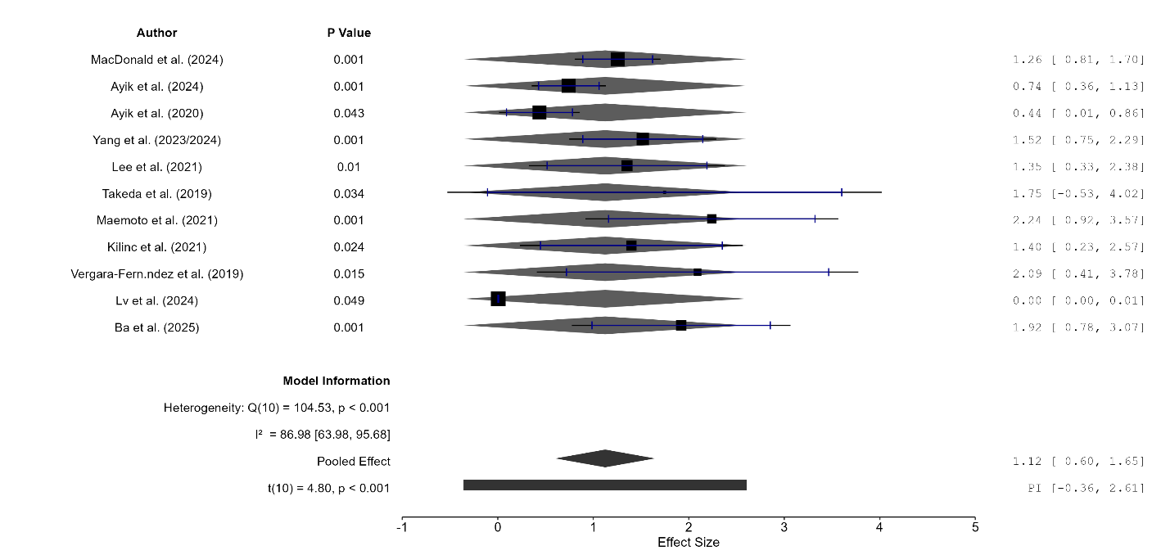
Figure 2. Forest Plot of Risk Factors for Complications in Patients with Intestinal Stoma
The forest plot showed that most articles had an effect direction that tended to increase the risk of complications, although the magnitude of effects varied across articles. The pooled effect showed a value of 1.12 with a CI of 0.60–1.65 and a p-value of < 0.001. Therefore, in general, the analyzed risk factors had a significant association with complications in patients with intestinal stoma. However, the heterogeneity value was high, namely Q(10) = 104.53; p < 0.001 and I² = 86.98%, indicating substantial variation in findings across articles. This condition suggests that differences in stoma type, patient characteristics, study design, type of complication, and clinical phase, such as stoma formation and stoma closure, may influence the effect size reported by each article.
The funnel plot was used to examine the distribution of articles based on residual value and standard error. The dots in the figure represent the analyzed articles, while the funnel-shaped lines indicate the expected distribution area if the article results are relatively balanced. A symmetrical distribution of dots around the center line usually indicates a lower possibility of publication bias.

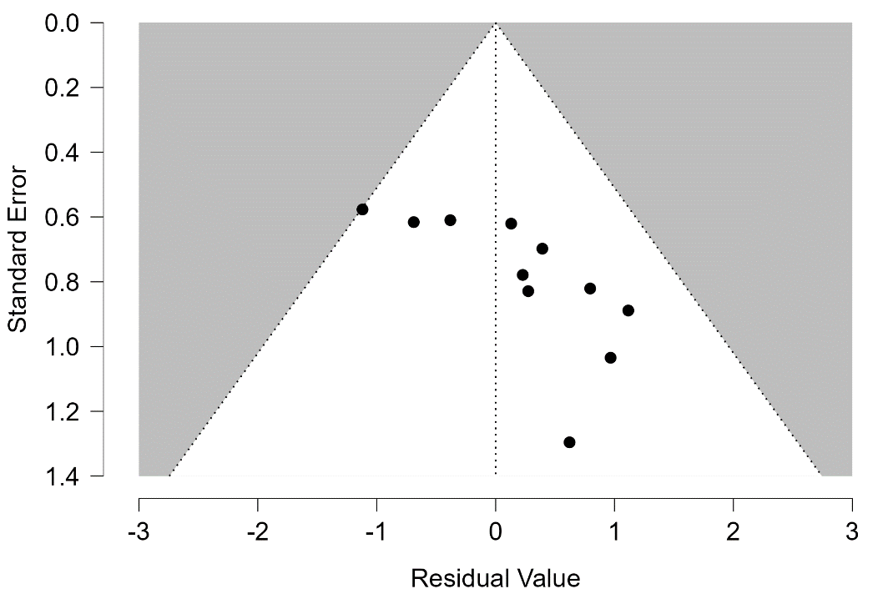
Figure 2. Funnel Plot Diagram
Figure 2 funnel plot shows that the distribution of articles was not fully symmetrical, as most points were located on the right side of the center line, while fewer points were found on the left side. Several articles also appeared in areas with larger standard errors, indicating variation in estimation precision across articles. This pattern suggests a possible imbalance in the distribution of results, which may be influenced by sample size, differences in outcomes, variations in study design, or the high heterogeneity observed in the forest plot.
Discuss
The results of this study show that postoperative complications in patients with intestinal stoma cannot be understood as a single outcome, because each article presented different clinical phases and types of complications. The synthesis of articles showed that stoma complications often occurred in the early phase after stoma formation, particularly in patients undergoing emergency surgery, patients with ileostomy, patients with more severe clinical conditions, and patients with technical problems related to stoma height and location. MacDonald et al. (2024) emphasized that research on emergency intestinal stoma formation aimed to assess the incidence of stoma-related complications and risk factors in this population, while Ayik et al. (2024) showed that early ostomy complications were more likely to occur after emergency colorectal surgery than after elective surgery. These findings strengthen the forest plot results, which showed that the overall direction of effect tended to be positive toward the risk of complications, although the strength of association across articles was not uniform. Steinhagen et al. (2017) also explained that peristomal skin complications occur more frequently in ileostomy than in colostomy, indicating that differences in stoma type should be considered an important source of clinical variation.
The risk factors identified in the included articles show that stoma complications are influenced by a combination of patient-related, procedural, and stoma care factors. Ayik et al. (2024) found that malignant disease, comorbidity, loop ostomy, female sex, neoadjuvant therapy, ileostomy, and ostomy height of less than 10 mm were associated with specific complications such as peristomal irritant contact dermatitis and mucocutaneous separation. MacDonald et al. (2024) also identified obesity and emergency surgery as important factors in complications after stoma formation. Chan et al. (2023) supported this finding through a systematic review that identified 22 potential risk factors for complications after stoma formation. This means that the risk of complications is not only inherent in the surgical decision itself, but also in preoperative preparedness, the patient’s physical condition, stoma configuration, and the quality of follow-up care. The high heterogeneity value in the meta-analysis can be understood because the analyzed articles did not assess exactly the same clinical phases and complications, ranging from early complications, high-output stoma, stoma-related obstruction, to complications after closure.
The difference between ileostomy and colostomy is an important issue in the discussion because these two types of stoma have different complication patterns. Yang et al. (2023/2024) showed that protective colostomy was more strongly associated with stoma retraction than protective ileostomy, whereas ileostomy is often associated with high-output stoma and fluid imbalance. The findings from Lee et al. (2021) and Takeda et al. (2019) in the SLR table also showed that high-output stoma and postoperative ileus may be associated with readmission and impaired patient recovery. Ge et al. (2023) added that comparisons between preventive loop ileostomy and colostomy revealed different complication patterns, such as a higher rate of prolapse in colostomy, while several other outcomes were not always significantly different. Therefore, the selection of stoma type should not only consider the purpose of anastomotic protection, but also the complication profile that patients may experience after hospital discharge.
Quality of life in patients with intestinal stoma is also an important part of the discussion because physical complications often develop into psychological, social, and functional barriers. Liu et al. (2021) examined quality of life among colorectal cancer patients with stoma using a quantitative cross-sectional design and assessed factors associated with patients’ quality of life. These findings are consistent with D’Ambrosio et al. (2022), who stated that peristomal skin complications are the most common skin problems after ostomy surgery and have an important impact on patients’ quality of life. Guerra et al. (2023) also assessed risk factors for dermatitis, pruritus/xerosis, infection, and ulceration in patients with stoma, further confirming that skin problems are not merely local complications but also part of patients’ daily lived experience. Therefore, quality of life should be understood as an outcome closely related to complications, self-care ability, pouch leakage, discomfort, and limitations in social activities.
Overall, the results of this SLR and meta-analysis show that intestinal stoma complications have a broad pattern, ranging from complications after stoma formation and problems during stoma use to complications after stoma closure. The funnel plot, which was not fully symmetrical, and the high heterogeneity value indicate that the results should be interpreted cautiously, especially because the articles differed in study design, stoma type, patient characteristics, and outcome definitions. Nevertheless, the overall direction of the findings provides a clear clinical message that complication prevention needs to begin in the preoperative phase through patient risk assessment, stoma site selection, stoma type selection, stoma care education, and peristomal skin monitoring. These results also emphasize that future studies need to present more standardized definitions of complications and more complete statistical reporting so that evidence regarding complication risks and quality of life in stoma patients can be compared more robustly across studies.

CONCLUSION
Hasil penelitian menunjukkan bahwa komplikasi pada pasien dengan intestinal stoma memiliki variasi yang luas, mulai dari komplikasi awal setelah pembentukan stoma, peristomal skin complication, mucocutaneous separation, high-output stoma, stoma-related obstruction, readmission, hingga komplikasi setelah stoma closure. Dari 12 artikel inklusi, sebagian besar penelitian menggunakan desain retrospektif dan lebih banyak membahas komplikasi stoma awal/postoperatif. Hasil meta-analisis menunjukkan pooled effect sebesar 1,12 dengan p < 0,001, sehingga faktor risiko yang dianalisis memiliki hubungan signifikan terhadap komplikasi pada pasien dengan intestinal stoma. Namun, nilai I² sebesar 86,98% menunjukkan heterogenitas tinggi, sehingga hasil perlu ditafsirkan dengan mempertimbangkan perbedaan jenis stoma, fase klinis, karakteristik pasien, dan definisi outcome antarartikel.
Implikasi penelitian ini menunjukkan bahwa pencegahan komplikasi stoma perlu dilakukan sejak tahap praoperatif, intraoperatif, hingga perawatan lanjutan setelah pasien pulang dari rumah sakit. Tenaga kesehatan perlu memperhatikan faktor risiko seperti jenis stoma, kondisi klinis pasien, operasi emergensi, tinggi stoma, penyakit penyerta, serta kebutuhan edukasi perawatan stoma. Pemantauan kulit peristomal, edukasi penggunaan kantong stoma, penguatan kemampuan perawatan mandiri, dan evaluasi berkala dapat membantu menurunkan risiko komplikasi serta menjaga kualitas hidup pasien. Bagi layanan kesehatan, hasil penelitian ini dapat menjadi dasar penguatan protokol perawatan stoma berbasis risiko.
Keterbatasan penelitian ini terletak pada variasi desain artikel, perbedaan jenis outcome, serta tingginya heterogenitas antarpenelitian. Selain itu, artikel mengenai kualitas hidup masih terbatas dibandingkan artikel yang membahas komplikasi klinis, sehingga sintesis kualitas hidup belum sekuat luaran komplikasi. Penelitian selanjutnya disarankan menggunakan definisi komplikasi yang lebih seragam, melaporkan data statistik secara lengkap, serta memisahkan analisis berdasarkan jenis stoma, waktu munculnya komplikasi, dan fase perawatan. Studi prospektif multisenter juga diperlukan agar hubungan antara faktor risiko, komplikasi, dan kualitas hidup pasien dengan intestinal stoma dapat dijelaskan secara lebih kuat.

REFERENCES
Açil, H. C., Yilmaz, A. Ç., & Aygin, D. (2025). The effect of recovery status and life conditions on the quality of life in colorectal cancer patients with stoma: A path analysis. Frontiers in Psychology, 16, 1693626. https://doi.org/10.3389/fpsyg.2025.1693626
Ambe, P. C., Kugler, C. M., Breuing, J., Grohmann, E., Friedel, J., Hess, S., & Pieper, D. (2022). The effect of preoperative stoma site marking on risk of stoma-related complications in patients with intestinal ostomy: A systematic review and meta-analysis. Colorectal Disease, 24(8), 904–917. https://doi.org/10.1111/codi.16118
Ayik, C., Bişgin, T., Cenan, D., Manoğlu, B., Özden, D., & Sökmen, S. (2024). Risk factors for early ostomy complications in emergency and elective colorectal surgery: A single-center retrospective cohort study. Scandinavian Journal of Surgery, 113(1), 50–59. https://doi.org/10.1177/14574969231190291
Ayik, C., Özden, D., & Cenan, D. (2020). Ostomy complications, risk factors, and applied nursing care: A retrospective, descriptive study. Wound Management & Prevention, 66(9), 20–30. https://doi.org/10.25270/wmp.2020.9.2030
Ba, M.-Q., Zheng, W.-L., Zhang, Y.-L., Zhang, L.-L., Chen, J.-J., Ma, J., & Huang, J.-L. (2025). Construction of a nomogram prediction model for early postoperative stoma complications of colorectal cancer. World Journal of Gastrointestinal Surgery, 17(1), 100547. https://doi.org/10.4240/wjgs.v17.i1.100547
Brady, R. R. W., Sheard, D., Howard, K., et al. (2025). The prevalence of leakage, peristomal skin complications and impact on quality of life in the first year following stoma surgery. Nursing Reports, 15(3), 107. https://doi.org/10.3390/nursrep15030107
Chan, M. S., Moore, Z., Patton, D., McNamara, D., O’Connor, T., & Avsar, P. (2023). A systematic review of patient risk factors for complications following stoma formation among adults undergoing colorectal surgery. International Journal of Colorectal Disease, 38, 238. https://doi.org/10.1007/s00384-023-04523-5
D’Ambrosio, F., Pappalardo, C., Scardigno, A., Maida, A., Ricciardi, R., & Calabrò, G. E. (2022). Peristomal skin complications in ileostomy and colostomy patients: What we need to know from a public health perspective. International Journal of Environmental Research and Public Health, 20(1), 79. https://doi.org/10.3390/ijerph20010079
Dellafiore, F., Caruso, R., Bonavina, L., Udugampolage, N. S., Villa, G., Russo, S., Vangone, I., Baroni, I., Di Pasquale, C., Nania, T., Manara, D. F., & Arrigoni, C. (2022). Risk factors and pooled incidence of intestinal stoma complications: Systematic review and meta-analysis. Current Medical Research and Opinion, 38(7), 1103–1113. https://doi.org/10.1080/03007995.2022.2081455
Díaz-Sánchez, C., Rodríguez-Muñoz, P. M., & colleagues. (2026). Impact of ostomy on quality of life in patients with colorectal cancer: A systematic review and meta-analysis. Healthcare.
Elnaim, A. L., Wong, M., & Sagap, I. (2024). Intestinal stomas; basics, complications and controversy: Systematic review. Academic Medicine & Surgery. https://doi.org/10.62186/001c.127121
Gan, J., et al. (2025). Prevalence and pooled risk factors of stoma outlet obstruction following colorectal surgery with diverting ileostomy: A meta-analysis. International Journal of Colorectal Disease, 40, 119.
Ge, Z., Zhao, X., Liu, Z., Yang, G., Wu, Q., Wang, X., Zhang, X., Cheng, Z., & Wang, K. (2023). Complications of preventive loop ileostomy versus colostomy: A meta-analysis, trial sequential analysis, and systematic review. BMC Surgery, 23, 235. https://doi.org/10.1186/s12893-023-02129-w
Glynn, J., Hollingworth, W., Harris, J., Mohiuddin, S., Ellis, L., Reeves, B. C., & Smart, N. (2025). The impact of parastomal hernia on quality of life using data from the CIPHER prospective cohort study. The European Journal of Health Economics, 26(7), 1209–1218. https://doi.org/10.1007/s10198-025-01768-5
Guerra, E., Denti, F. C., Di Pasquale, C., Caroppo, F., Angileri, L., Cioni, M., Parodi, A., Fortina, A. B., Ferrucci, S., & Burlando, M. (2023). Peristomal skin complications: Detailed analysis of a web-based survey and predictive risk factors. Healthcare, 11(13), 1823. https://doi.org/10.3390/healthcare11131823
Higgins, J. P. T., Thomas, J., Chandler, J., Cumpston, M., Li, T., Page, M. J., & Welch, V. A. (Eds.). (2024). Cochrane handbook for systematic reviews of interventions (Version 6.5). Cochrane. https://www.cochrane.org/authors/handbooks-and-manuals/handbook/current
Jose, A., Kothari, R., Sharma, D. B., & Sharma, D. (2025). Incidence and impact of peristomal candidiasis on outcomes after intestinal stoma closure: A prospective study. Tropical Doctor, 55(2), 121–123. https://doi.org/10.1177/00494755251329636
Kilinc, G., Ustun, M., Tuncer, K., & Sert, I. (2021). Risk factors for the morbidity and mortality of stoma closure. Journal of the College of Physicians and Surgeons Pakistan, 31(9), 1085–1088. https://doi.org/10.29271/jcpsp.2021.09.1085
Lee, N., Lee, S. Y., Kim, C. H., Kwak, H. D., Ju, J. K., & Kim, H. R. (2021). The relationship between high-output stomas, postoperative ileus, and readmission after rectal cancer surgery with diverting ileostomy. Annals of Coloproctology, 37(1), 44–50. https://doi.org/10.3393/ac.2020.08.03
Leite Junior, V. d. O., Vieira, G. G., Lima, K. S., Costa, S. M., Carvalho, A. R. B. d., Soeiro, V. M. d. S., Silva Caldas, A. C., Abreu Lima, R., Ribeiro Azevedo, P., Silva Dias, R., & Alves de Sousa, S. d. M. (2025). Quality of life and its determinants in older adults with intestinal stomas: A cross-sectional study. International Journal of Environmental Research and Public Health, 22(3), 375. https://doi.org/10.3390/ijerph22030375
Liu, H., Zhu, X., Yu, J., He, P., Shen, B., Tang, X., Xu, X., Wei, D., Chen, Y., & Li, X. (2021). The quality of life of patients with colorectal cancer and a stoma in China: A quantitative cross-sectional study. Advances in Skin & Wound Care, 34(6), 302–309. https://doi.org/10.1097/01.ASW.0000744348.32773.b9
Lupo, R., Rubbi, I., Barletta, A., Mele, C., Lezzi, A., Botrugno, I., Mottillo, G., Manca, D., Potì, O., Triglia, C., et al. (2025). Quality of life and psychophysical consequences in individuals with intestinal stoma: An observational study. International Journal of Environmental Research and Public Health, 22(9), 1327. https://doi.org/10.3390/ijerph22091327
Lv, Q., Yuan, Y., & Xiang, Z. (2024). Analysis of risk factors for the sigmoid stoma complications in patients after abdominoperineal resection surgery: An observational study. Medicine, 103(26), e38751. https://doi.org/10.1097/MD.0000000000038751
MacDonald, S., Wong, L.-S., Ng, H. J., Hastings, C., Ross, I., Quasim, T., & Moug, S. J. (2024). Post-operative outcomes and identification of risk factors for complications after emergency intestinal stoma surgery: A multi-centre retrospective study. Colorectal Disease, 26(5), 994–1003. https://doi.org/10.1111/codi.16947
Maemoto, R., Tsujinaka, S., Miyakura, Y., Fukuda, R., Kakizawa, N., Takenami, T., Machida, E., Kikuchi, N., Kanemitsu, R., Tamaki, S., Ishikawa, H., & Rikiyama, T. (2021). Risk factors and management of stoma-related obstruction after laparoscopic colorectal surgery with diverting ileostomy. Asian Journal of Surgery, 44(8), 1037–1042. https://doi.org/10.1016/j.asjsur.2021.01.002
Nozawa, H., Sasaki, S., Hayashi, C., Kawasaki, A., Sasaki, K., Murono, K., Emoto, S., & Ishihara, S. (2024). Preoperative stoma site marking reduces postoperative stoma-related complications in emergency surgery: A single center retrospective cohort study. Scandinavian Journal of Surgery, 113(1), 40–49. https://doi.org/10.1177/14574969231186282
Page, M. J., McKenzie, J. E., Bossuyt, P. M., Boutron, I., Hoffmann, T. C., Mulrow, C. D., Shamseer, L., Tetzlaff, J. M., Akl, E. A., Brennan, S. E., Chou, R., Glanville, J., Grimshaw, J. M., Hróbjartsson, A., Lalu, M. M., Li, T., Loder, E. W., Mayo-Wilson, E., McDonald, S., … Moher, D. (2021). The PRISMA 2020 statement: An updated guideline for reporting systematic reviews. BMJ, 372, n71. https://doi.org/10.1136/bmj.n71
Poliani, A., et al. (2026). Stoma leakage: Prevalence, associated factors, and assessment tools—A scoping review. Nursing Reports, 16(2), 46. https://doi.org/10.3390/nursrep16020046
Qassim, T., Saeed, M. F., Qassim, A., Al-Rawi, S., Al-Salmi, S., Salman, M. T., Al-Saadi, I., Almutawea, A., Aljahmi, E., Fadhul, M. K., & Juma, I. M. (2023). Intestinal stomas—Current practice and challenges: An institutional review. Euroasian Journal of Hepato-Gastroenterology, 13(2), 115–119. https://doi.org/10.5005/jp-journals-10018-1404
Shiraishi, T., Ogawa, H., Katayama, C., Osone, K., Okada, T., Katoh, R., Sano, A., Sakai, M., Sohda, M., Shirabe, K., & Saeki, H. (2025). Association of chemotherapy and stoma features with peristomal skin disorders in malignant rectal tumor patients: A prospective multicenter observational study. International Wound Journal.
Sritan, S. (2023). Factors contributing to the quality of life among Thai patients diagnosed with colorectal cancer with a stoma: An integrative review. Journal of Advanced Nursing, 79, 1–14. https://doi.org/10.1111/jan.15460
Steinhagen, E., Colwell, J., & Cannon, L. M. (2017). Intestinal stomas—Postoperative stoma care and peristomal skin complications. Clinics in Colon and Rectal Surgery, 30(3), 184–192. https://doi.org/10.1055/s-0037-1598159
Takeda, M., Takahashi, H., Haraguchi, N., Miyoshi, N., Hata, T., Yamamoto, H., Matsuda, C., Mizushima, T., Doki, Y., & Mori, M. (2019). Factors predictive of high-output ileostomy: A retrospective single-center comparative study. Surgery Today, 49(6), 482–487. https://doi.org/10.1007/s00595-018-1756-2
Toffaha, A. T., et al. (2025). Risk factors for stoma outlet obstruction: Systematic review and meta-analysis. Langenbeck’s Archives of Surgery. https://doi.org/10.1007/s00423-025-03892-5
Vergara-Fernández, O., Trejo-Avila, M., & Salgado-Nesme, N. (2019). Multivariate analysis of risk factors for complications after loop ileostomy closure. Cirugía y Cirujanos, 87(3), 337–346. https://doi.org/10.24875/CIRU.18000611
Yang, Y.-W., Huang, S.-C., Cheng, H.-H., Chang, S.-C., Jiang, J.-K., Wang, H.-S., Lin, C.-C., Lin, H.-H., & Lan, Y.-T. (2024). Protective loop ileostomy or colostomy? A risk evaluation of all common complications. Annals of Coloproctology, 40(6), 580–587. https://doi.org/10.3393/ac.2022.00710.0101
Zeng, Z., Hu, Y., Hou, S., Yang, R., Shi, Z., & Li, X. (2025). Risk factors for complications after infantile enterostomy: Development of a clinical prediction model. Frontiers in Public Health, 13, 1566789. https://doi.org/10.3389/fpubh.2025.1566789
Zewude, W. C., Derese, T., Suga, Y., & Teklewold, B. (2021). Quality of life in patients living with stoma. Ethiopian Journal of Health Sciences, 31(5), 993–1000. https://doi.org/10.4314/ejhs.v31i5.11
Zhou, L., Qin, Z., & Wang, L. (2023). Risk factors and incidence of non-closure stoma in patients with anterior resection of rectal cancer with temporary stoma: A systematic review and meta-analysis. European Journal of Surgical Oncology, 49(12), 107120. https://doi.org/10.1016/j.ejso.2023.107120

